Be The Goalie – Play On

Technical Guidelines

This installation is fundamentally made up of a table football table (‘Table’) and two wall structures (‘Walls’), one labelled with red vinyl stickers, the other labelled with blue vinyl stickers, corresponding to the team colours at the closest end of the Table. Each Wall has a desktop computer in the cabinet on the rear (‘Computer Cabinet’). Along the top runs a beam (‘Crossbar’). On top of each Crossbar sits a depth sensing camera (‘Kinect sensor’/’Kinect’).

The computers in each Wall run entirely independently of each other. The only data passed between the Walls are clock events, which are provided by one of the embedded computers inside the Table.

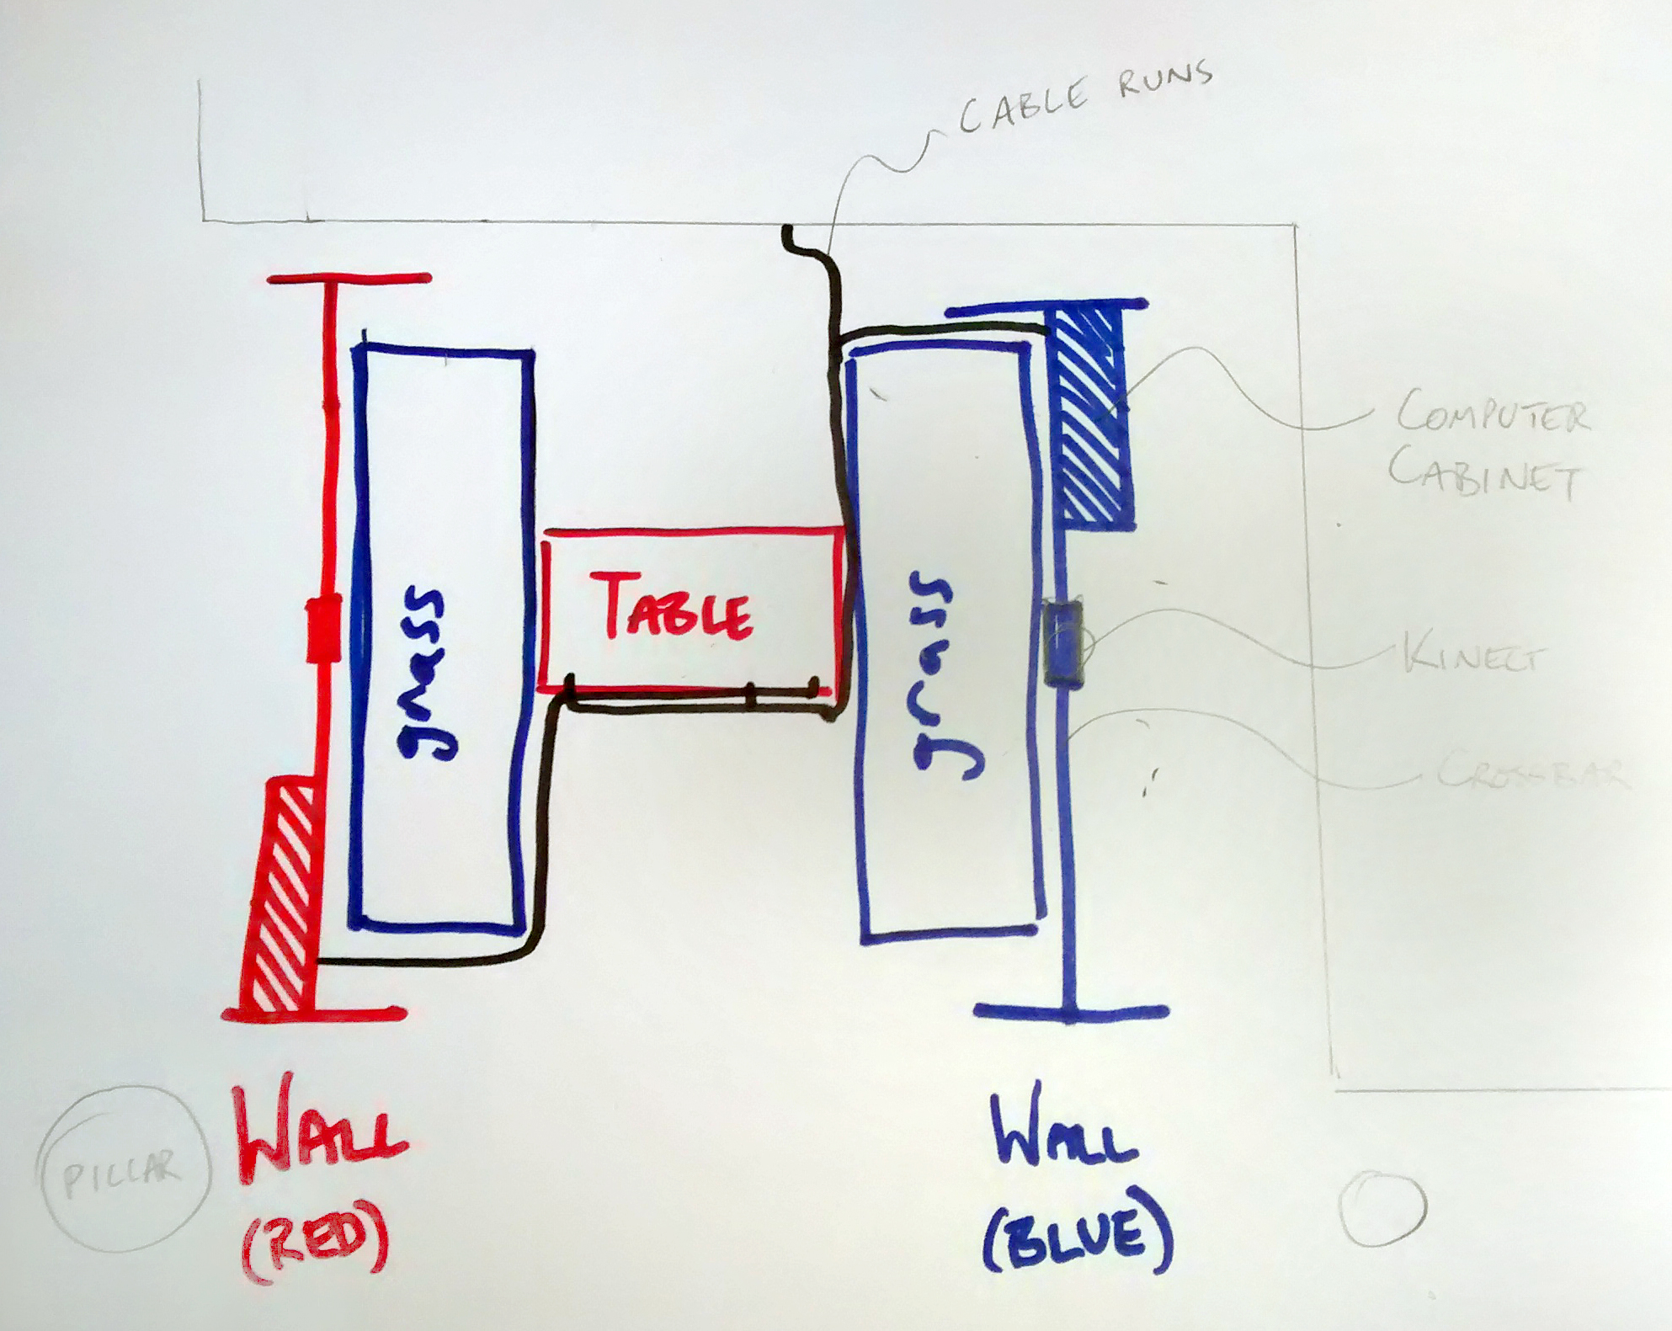

# Accessing Computer Cabinets

The top lid is removable without tools, and the front panel is removable using a screw driver.

# Removing the lid:

1. Pull out the pin on the left of the cabinet and lift up the left side of the lid.
2. Slide the whole lid to the left and off the cabinet.

# Replacing the lid:

1. Present the lid to the top of the cabinet, matching the coloured diamond sticker in one corner to its partner inside the cabinet. The diamond sticker on the lid should face down into the Computer Cabinet.
2. Locate the bolt on the right end of the lid in its hole.
3. Lower the left side of the lid into place.
4. Push the pin on the left of the cabinet all the way into its hole.

# Removing the front panel:

* Unscrew all six screws on the front surface, starting at the bottom. Keep them and their cup washers safe for later.

# Replacing the front panel:

1. Present the panel to the Computer Cabinet, matching the coloured sticker in one corner to its partner inside the cabinet. The sticker on the front panel should face into the Computer Cabinet.
2. Screw in all six screws, ensuring the cup washers are in place, starting at the top. Ensure that the screws go into their existing holes in the Computer Cabinet.

# Powering Up

# Table (do this first):

* Switch Table on using on/off switch on the underside of the Table, near the power cord. Various lights inside the table should come on. If the Walls are already on, then a few lights will already be lit inside the table.

# Walls (do this after the Table):

Do this for each wall:

1. Switch on mains power to the Wall. If there is a black extension under the Computer Cabinet, pull it out carefully by the cord and check that any power light on it is on, and any switches are set to the on position. Lights should come on inside the Computer Cabinet, you will hear the speakers humming, and the scoreboard on the front may show two lines.
2. Remove the top lid of the Computer Cabinet (see above).
3. Turn on the computer by pressing the power button to the right of the USB ports, indicated by a coloured sticker. A blue light should come on round the corner beneath the power button.
4. Check that the monitor on the Wall is turned on - a light should show in the bottom right when it is on. If not, it has a power button on the bottom right, to the left of the light.

# Powering Down

# Table:

* Switch Table off using on/off switch on the underside of the Table, near the power cord. Most lights inside the table should go off. If the Walls are still on, then a few lights will remain on in the table.

# Walls:

Do this for each Wall:

1. Remove the top lid of the Computer Cabinet (see above).
2. Shut down the computer by pressing the power button to the right of the USB ports, indicated by a coloured sticker. The blue light round the corner beneath the power button should go off when shut down is complete. Lights will remain on inside the Computer Cabinet, you will hear the speakers humming, and the scoreboard on the front should show two lines.
3. Replace the top lid of the Computer Cabinet (see above).
4. Switch off mains power to the Wall. If there is a black extension under the Computer Cabinet you can switch off here - pull it out carefully by the cord and flip all switches to the off position. The speakers should be silent and scoreboard off.

# Resetting

If you think the installation needs to be reset, do it in this order:

* Reset the Table by briefly pressing the red button on the underside of the Table, next to the power switch.

If you also think you need to reset the computers, do this as needed for each Wall. Remember that the camera in the Wall is trained on the person at the *opposite* end, and controlling the goalie at that opposite end:

1. Remove the top lid of the Computer Cabinet (see above).
2. Shut down the computer by pressing the power button to the right of the USB ports. The blue light round the corner beneath the power button should go off when shut down is complete.
3. When shut down is complete, turn on the computer by pressing the same power button. The same blue light should come on.
4. Replace the top lid of the Computer Cabinet (see above).

# Removing for evening event

1. Power down the whole installation (see above). While you have the lids off the Computer Cabinets, unplug the Kinect sensors from their socket at the top left of the Computer Cabinet (marked ‘K’).
2. Remove the power cord from the underside of the Table. Stow the power cord and any extensions for later.
3. Remove the two data cables that run from the Walls to the Table. Stow for later.

Do this for each Wall:

1. Switch off the power to the Wall at the extension under the Wall’s Computer Cabinet – you can pull the extension out of its Computer Cabinet carefully by the cord.
2. Remove the white power plug for the Wall from its extension or mains socket. Stow any extensions for later.
3. Undo the velcro cable ties for the Kinect sensor cable. Remove the cable up to the Crossbar and tie it in a bundle there.
4. Roll up the grass mats.
5. Remove the central Wall panel by removing the four pins from their hinges and moving it out to the rear. Stow the pins carefully for later.
6. **Two people:** With a person at either end, slide the Cross bar up and off the Wall Ends. Set it down on the floor.

The whole installation should now be in 16 components: 1 x Table, 2 x Wall Ends, 2 x Wall Ends with Computer Cabinets, 2 x central Wall panels, 2 x Crossbars, 2 x grass mats, 5 x power/data cables + any cable covers.

1. **Two people:** Lift each component onto trolleys and remove from the gallery. Ensure front panels are attached to Wall ends before moving.

# Reinstating after evening event

The whole installation should be in 16 components: 1 x Table, 2 x Wall Ends, 2 x Wall Ends with Computer Cabinets, 2 x central Wall panels, 2 x Crossbars, 2 x grass mats, 5 x power/data cables + any cable covers.

1. **Two people:** Lift onto trolleys and bring into gallery.
2. Position the components as described below, ensuring the Table is oriented so that the correctly coloured team at each end correspond with the nearest wall:

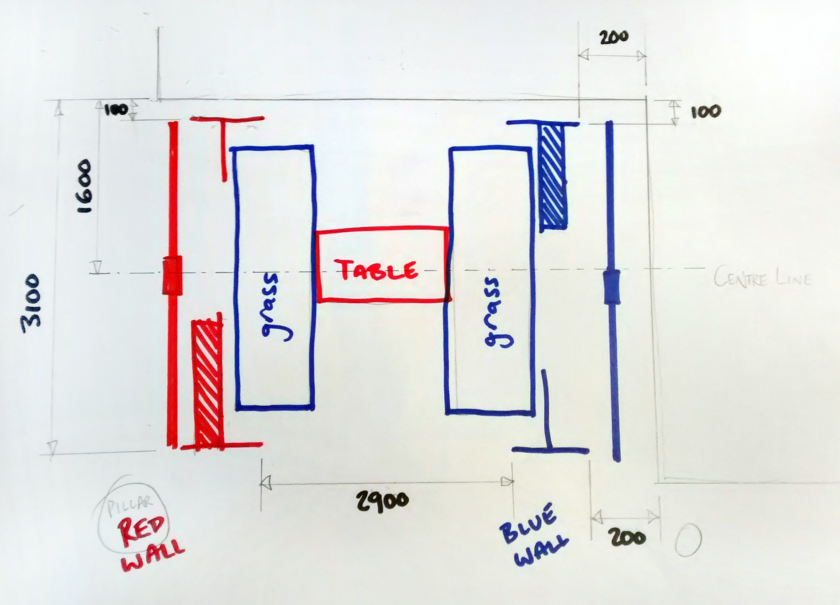

Do this for each Wall:

1. **Two people**: With a person at either end, lift up the Crossbar and slide it down onto the tops of the wall ends (it helps if you start with the longer Computer Cabinet wall end, as the other wall end is easier to manoeuvre afterwards). The tabs at the top of the wall ends fit into the slots in the Crossbar.
2. **Two people**: Fit the central Wall panel by presenting it to the Wall from the rear, aligning the hinges and inserting the four pins into the hinges.
3. Place the Kinect sensor cable into its velcro ties, leading to the Computer Cabinet.
4. Remove the Computer Cabinet lid (see above) and plug the Kinect sensor into its socket at the top left of the Computer Cabinet (marked ‘K’).
5. Reinstate the power cables to each Wall and the Table.
6. Plug the data cables in. They run from a socket at the front bottom left of each Wall, to a socket at the *opposite* end of the football table. Ensure that red plugs run to red sockets, and blue plugs to blue sockets.
7. Switch on power at mains and extensions.

The installation is now ready to power up (see above).

# Realigning the Kinect view

This should not normally be necessary, but misalignment may occur in the process of removing and reinstating the installation. If you think the Kinect is not properly aligned, you can adjust it:

1. Standing at the rear of the Wall, reach up through the space in the middle of the Wall to the Kinect Sensor.
2. Keeping an eye on the computer monitor on the rear of the Wall, carefully adjust the camera until the darker bars at the sides of the black and white image frame the opposite wall centrally left to right. Similarly, the wall should appear centralised vertically in the black and white image.

# Understanding Error Codes

The computer monitors on the rear of the walls may show error phrases that could point to simple connection problems. Errors appear at the top of the monitor screen.

* NO SERIAL PORTS. / ONLY ONE SERIAL PORT .– Connection problem. Check that the USB plugs for the scoreboard and leading to the data socket are properly inserted at both ends.
* NO KINECT. – Connection problem. Check that the USB plug for the Kinect Sensor is properly inserted into the computer, and that the Kinect Sensor is properly plugged into its power socket in the top left of the Computer Cabinet (marked ‘K’).
* PORTS INVERTED. – This is an internal error, only useful for more in-depth debugging – the installation can run fine despite this error, and there isn’t anything one can do to remove it if it appears.
* PORTS OK. – Everything is fine!

# Support

Telephone Roy on 07974896651 or email [roy@000111.co.uk](mailto:roy@000111.co.uk) .